# Food Waste Supply Curve Construction and Documentation

Prepared by Alex Badgett, Emily Newes, and Anelia Milbrandt

National Renewable Energy Laboratory

# 1. Introduction

The U.S. Department of Energy’s Bioenergy Technology Office (BETO) has begun exploring the bioenergy feedstock potential of the following residential, commercial, and industrial wastes:

* Food waste
* Fats, Oils, and Greases (FOG)
* Sewage sludge
* Animal manure

These materials are produced from various industries and are conventionally difficult to manage and safely dispose of. A low willingness to dispose of these wastes means that they could be available for use as bioenergy feedstocks, and at economically favorable costs. This document specifically characterizes construction of economic models for food waste.

We build upon results published in Milbrandt et al. (2017), which provides an assessment of the total and available wet Waste-to-Energy (WTE) resource potential in the United States and illustrates its geographic distribution.[1]

This work supplements the aforementioned analysis by characterizing the economic drivers of food waste management and developing supply curves for the material. Understanding the economics of waste materials that are not conventionally treated like commodities by their handlers required a different, more flexible approach towards understanding the industry. The supply curves shown in this document depict material economics at a nationwide level; however future work will focus on supply curves for states and regions.

It often costs operators money to dispose of food waste safely and in accordance with regulatory standards, which vary widely among states, cities, and counties.[2] This suggests that operators would be willing to pay a dollar per ton amount for food waste to be taken away and disposed for them. This work seeks to quantify that value, and refers to it as “avoided cost”. This is the cost that food waste producers would be willing to pay a bioenergy plant to accept the material, as long as it is below the dollar per weight value they currently must pay to dispose of it.

From Milbrandt et al. (2017), food waste is commonly generated at several points:

* Residential households
* Commercial food service operations (supermarkets, restaurants)
* Industrial (food processers, meat packing plants, etc.)
* Institutional (educational, hospitals, hotels, etc.)

In this work, we considered food waste after it has been collected from these point sources and aggregated at a central waste processing facility.

# 2. Process Flow

Depending on local regulations and infrastructure, collected food waste can be comingled with other municipal solid waste (MSW), recyclables or it may be collected separately.[2] Our model assumes that a waste management company collects food waste from various sources and comes comingled with MSW, which is then transported it to a central location. This location can take several different forms, and in general is one of the following:

* Transfer Station (TS) which transfers municipal waste to long-haul trucks for landfill disposal
* Materials Recovery Facility (MRF) focused on recovering recyclable materials (aluminum, paper, cardboard, etc.)
* Landfill for direct waste disposal

We then adapted this model under a WTE scenario, where we assumed the food waste was diverted from landfill disposal to a WTE-oriented end use. Under this scenario, modeled costs were differentiated into two types:

* **Avoided**: costs that food waste processers are currently paying to dispose of the material, and would be willing to pay a WTE consumer to take food waste
* **Additional costs**: costs of infrastructure, labor, and resources necessary to process food waste for use as a WTE feedstock

These costs are presented in Figure 1 below. Of the avoided costs, we considered only landfill disposal. This is the most prevalent alternative across the country, and sites already incorporating the other disposal technologies are not likely to seek development of WTE technologies.

.



Figure : Cost model WTE scenario. Costs for sorting food waste and preparing it into a slurry are considered added costs. Landfill tipping fees are the avoided costs considered in this work.

To aggregate food waste as a WTE feedstock, it must be separated from MSW and other non-organics. There is not extensive literature on the cost of facilities designed to separate organic fractions of MSW, therefore costs were modeled based on those for a MRF. MRFs are used to separate recyclables from MSW, and can be developed for either mixed or single stream wastes. We altered the required MRF component technologies to depict a facility that processes organic material, as shown later in Figure 3.

The cost of constructing and operating a MRF along with depackaging and creating a slurry with the food waste were considered additional costs, while the landfill tipping fee is an avoided cost. The cost of food waste from the perspective of a WTE facility is therefore calculated by subtracting the landfill tipping fee from the sorting cost, as illustrated in the below equation.

$$C_{fw}=C_{add}-C_{av}$$

when:

Cadd= Additional costs

Cav=Avoided costs

If the resulting value is negative, it indicates that the user could be paid to take the material, or receive it at no cost. Positive values suggest that a WTE user would need to pay to acquire the material for use as a feedstock. Figure 2 documents the model process for calculating the cost of an organics sorting facility, with the applicable literature and datasets used listed outside the yellow brackets.

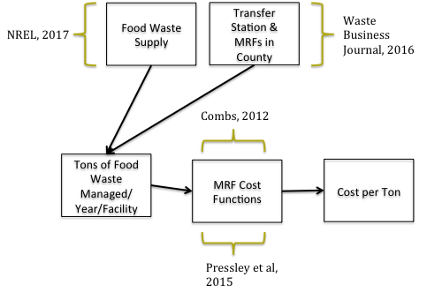

Milbrandt et al, 2017

Figure : Model process flow for evaluating capital and operational costs of an organic waste sorting facility

Cost functions for MRFs were adapted from Pressley et al. (2015) and Combs (2012). [3], [4] Both texts conducted life cycle analyses on MRFs, and modeled the economics of these facilities. The work of Pressley et al. (2015) is based on economic fundamentals defined in Combs (2012). Combs defined functions for MRF costs as a function of throughput capacity of the plant. Both analyses considered MRFs designed for recovering recyclable metals, paper, and plastics. A MRF designed to recover organics is likely to differ slightly in design from one aimed at recovering recyclables; however, costs are largely still applicable,[1] and were adjusted as necessary.

Several states, cities, and counties have implemented bans on disposing of food waste in landfills. These bans can apply to different entities: residential, commercial, industrial, or some segment of the three, with significant variations between bans. Under these laws, food waste cannot be disposed of in MSW-operators must collect it separately, thereby avoiding the cost of developing a sorting facility for organic waste. Costs for diverting food waste are already footed by its collectors and producers, reducing the cost for a consumer of food waste as a WTE feedstock. These bans are further suited for WTE development as most state regulations define where the diverted food waste is to be sent. State laws that cover WTE facilities as allowable disposal alternatives effectively guarantee a low-cost supply of food waste feedstock to the facility. If the state where the cost is being modeled has implemented an organic waste ban, our model sets the sorting cost to equal zero and the model bypasses developing MRF costs.

We recognized that many counties already have transfer stations or recyclables MRFs in operation. These sites could be adapted to process organics in conjunction with other waste materials at a lower cost per wet ton than is required for construction of a new organics MRF. To account for this, we modeled the following scenarios in this work:

* **Capital cost scenario**: considers full cost of construction of an organics MRF
* **Add-on cost scenario**: considers costs of adapting existing MRF, TS, or LF to handle food waste

Figure 3 shows our model cost components with pink shaded boxes representing the component costs **not** considered under the add-on scenario (along with neglected capital costs of the facility). All component costs shown are included in the capital cost scenario.

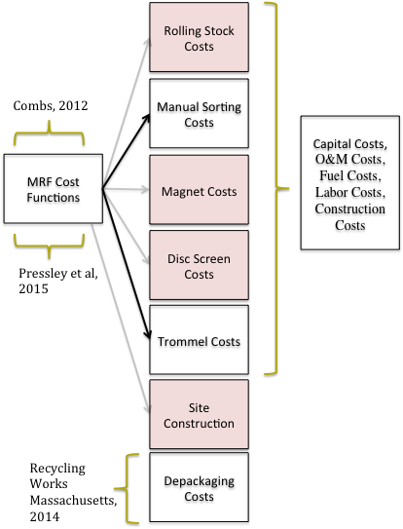

Figure 3: Modeled MRF cost components under the add-on cost scenario (red) and capital cost scenario (all boxes).

Figure 4 shows the resulting cost curves for each scenario as a function of the wet tons of food waste a plant processes per day. The increase in cost per wet tons per day mark under the capital cost scenario is produced when the model increases the number of rolling stock (haul trucks) needed to process the larger amounts of waste.

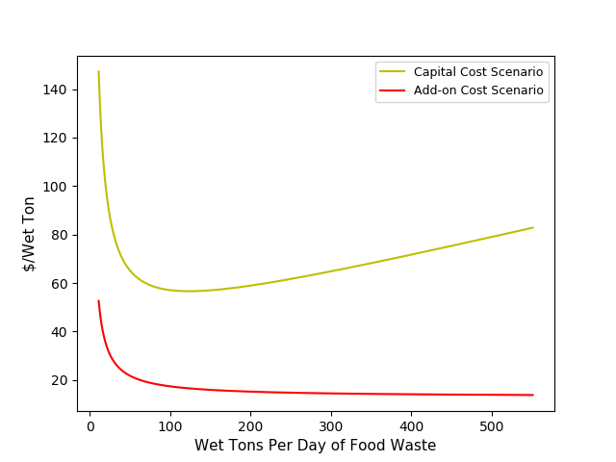

Figure 4: MRF sorting cost curves for capital cost and add-on cost scenarios. The rise seen in the capital cost curve occurs when the model increases the number of rolling stock vehicles in response to the higher amount of wet tons managed per day.

# 3. Limitations

This section discusses limitations encountered during modeling food waste economics and strategies for managing them.

## 3.1 MRF Cost Data

A notable limiting factor within this work is the lack of publicly available data for the cost of building and operating organic waste sorting facilities. None of the reviewed literature provided estimates for the cost of these facilities; therefore, costs were based on MRFs processing recycled materials. These facilities are largely similar in overall design and operation; however, the materials they process are different. Different types of recyclable MRFs exist: those handling mixed MSW and those handling pre-sorted recyclables. This work focused on costs of MRFs managing mixed MSW, as their operations are likely to be most analogous to facilities processing strictly organics. Several sources exist for estimating the component costs of these facilities, however many were developed before 2000. The increase in automation of MRF operations since 2000 has altered the degree to which many of these models are applicable. [3] Therefore modeling of MRF cost was based on that presented in Combs, 2012. [4]

## 3.2 Organic Waste Ban Implementation

Several US states, cities, and counties have enacted bans of disposing food waste in normal MSW landfills. The model assumes the sorting cost for all food waste generated within the covered area is equal to zero, as it must already be separated from MSW when disposed of. Our model does not currently capture differences in the structuring and applicability of these bans. For instance, many bans do not apply to entities producing below a defined waste threshold (e.g. 52 tons of waste per week). This waste is still being sent to landfills, however the model considers all organic waste within the state is available at no cost. This creates an overestimate of the amount of food waste available at a negative cost within that state, as not all portions of food waste are likely to be regulated under the organic ban.

Secondly, several organic waste bans specifically emphasize using diverted food waste as composting material. [2] This emphasis creates competition among end-uses for food waste, and influences the feasibility of using the material as a WTE feedstock.

## 3.3 Small Food Waste Producers

Food waste generation is proportional to population and infrastructure centers [1] and varies widely by geographic area. By geospatially aggregating a dataset of transfer stations, landfills, and MRFs across the country [5], the number of each within every county was determined and inputted into the model. This allows for an estimation of the average tons of food waste that each facility would process per day within the county. These facilities are also located proportionally to population centers and infrastructure. Counties without sufficient development did not have any MRFs, transfer stations or landfills, likely because not enough waste was produced to justify construction of one. In these cases, waste is most likely transported to a disposal site in an adjacent county. For these counties, the model assumes construction of a single MRF to handle the waste produced there. The ratio of counties without an LF, MRF, or TS to those with is shown in Figure 5.

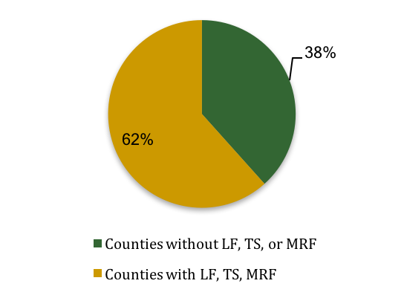

Figure 5: Percentage of US counties with a landfill (LF), transfer station (TS), or materials recovery facility (MRF) versus those without. Data from Waste Business Journal, 2016.

# 4. Data Sources

Several datasets were aggregated and incorporated into this work. Data on regional economics, food waste production, waste management infrastructure, and energy prices were integrated in the developed model. Datasets are listed in Table 1, with sources and scale of each also noted.

Table : Dataset source and descriptions

|  |  |  |  |
| --- | --- | --- | --- |
| Dataset | Description | Scale | Source |
| Hourly wages | Refuse and recyclable material collectors hourly wage | State | Bureau of Labor Statistics, 2016 [6] |
| MRF, transfer stations and landfills | Locations and tipping fees | Point | Waste Business Journal, 2016 [5] |
| Food waste production | Food waste production values in wet tons | County | Milbrandt et al, 2017 [1] |
| Diesel cost | Cost for diesel fuel in $/gallon | State | Energy Information Administration, 2017 [7] |
| Electricity cost | Cost of electricity in $/kWhr | State | Energy Information Administration, 2017 [8] |
| Depackaging | Summary of food depackaging technologies | National | Recycling Works Massachusetts, 2014 [9] |

# 5. Supply Curves

This section presents modeled national supply curves for food waste and discusses pertinent aspects of those curves.

Two food waste sorting cost scenarios were modeled as part of this work:

1. Costs for sorting included full capital and construction costs associated with constructing a new standalone organics MRF (capital cost scenario)
2. Costs for sorting were limited to supplemental equipment needed to modify an existing waste management facility to process food waste (add-on cost scenario)

Our model considers if there is an existing MRF, TS or landfill within the county, and if so assigns the add-on cost scenario. This is under the assumption that any food WTE project would be developed on that site to minimize capital and operating expenses. If no such facility exists, the model assigns the capital cost scenario, assuming a standalone processing facility would be constructed. As Illustrated in Figure 6, these scenarios produce a varied aggregate supply curve, with a majority of food waste available at a low cost, but becoming prohibitively expensive quickly when including small amounts of food waste produced in areas without existing waste management infrastructure.

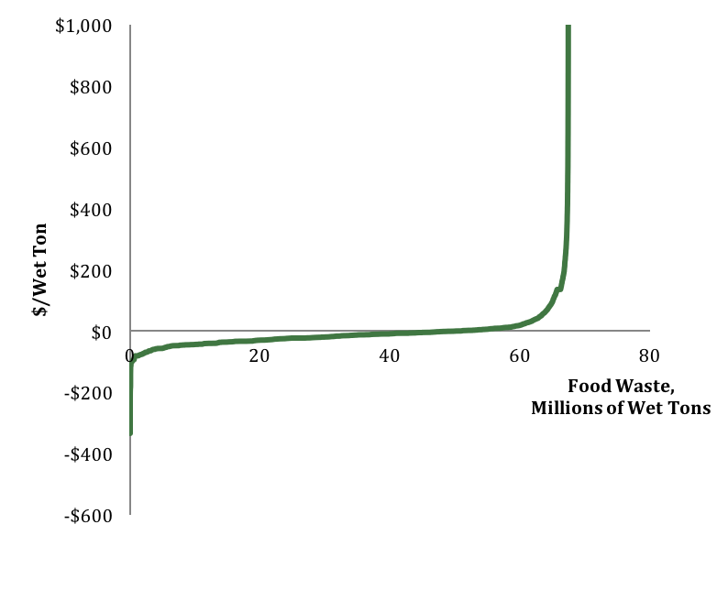

Capital cost scenario & low FW production

Add-on scenario & organics bans

Figure 6: National food waste supply curve.

If a state where the cost is being computed has implemented an organic waste ban, the sorting cost was set to equal zero, and the cost of food waste was assumed to be the avoided (negative) cost of the landfill tipping fee less a depackaging and slurry creation cost. These states immediately fell under the negative cost section of the curve since the avoided landfill tipping fee is greater than the additional processing costs. This means that a portion of each curve is always mapped as negative, as states with organic waste bans had food waste modeled at negative costs.

Areas with extremely high tipping fees (greater than costs for sorting and depackaging food waste) and existing waste infrastructure (add-on cost scenario) can also produce negative food waste costs. This is the main driver behind the higher amount of food waste available at a negative cost in counties with existing waste processing facilities, because the lower cost per ton of sorting food waste increases the chances that the landfill tipping fee will be greater than costs of additional processing.

Figure 6 shows a relatively low price for the majority of food waste, which increases drastically in areas with low food waste production and no waste management infrastructure. Figure 7 explores this difference further by mapping costs per wet ton for every county in the United States under the two possible county scenarios.

Costs for the add-on cost scenario center around zero, while the capital cost scenario produces costs per ton that are higher and exhibit a wider distribution. This difference in cost is the primary driver behind the different supply curves presented above.

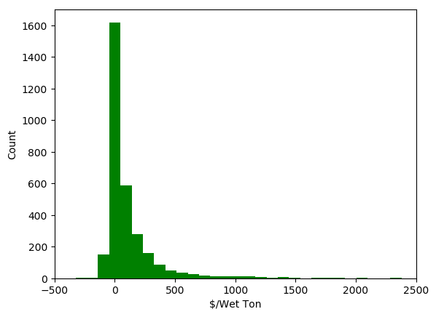

Figure 7: Cost per wet ton distribution for food waste.

# 6. State Supply Curves

Since the food waste economic model was built to operate at a county level, results can be aggregated into either state or national supply curves. Figure 8 shows a cluster of supply curves for all 50 U.S. states. As seen in the national supply curves in Figure 6, portions of the supply curve put food waste at a negative cost and others at a positive cost. The add-on cost scenario produces more state supply curves with negative cost feedstocks, as expected with the lower cost per ton of sorting.

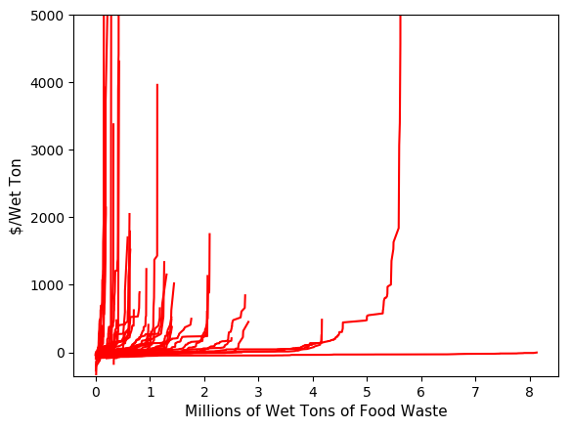

Figure 8: Food waste supply curves for all 50 US states

# 7. Future Work

Future work will characterize the available MSW processing infrastructure across the country, and how food waste sorting facilities affect the economics of these sites. Variations between sites with respect to equipment and degree of sorting automation are expected, and a conceptual framework for food waste sorting will be developed to account for these variations. Accurately understanding what level of capital investment is necessary to sort and process food waste for use as a WTE feedstock directly relates to the economic viability of its potential use in the WTE industry.

# 8. References

[1] A. Milbrandt, T. Seiple, D. Heimiller, R. Skaggs, and A. Coleman, “Wet Waste-to-Energy Resource Assessment (Pending Publication).”

[2] A. Badgett and A. Milbrandt, “Policy Analysis of Wet Waste-to-Energy Feedstocks (In progress),” National Renewable Energy Laboratory.

[3] P. Pressley, J. Levis, A. Damgaard, M. A. Barlaz, and J. F. DeCarolis, “Analysis of Material Recovery Facilities for Use in Life-Cycle Assessment,” *Waste Manag.*, vol. 35, pp. 307–317, 2015.

[4] A. R. Combs, “Life Cycle Analysis of Recycling Facilities in a Carbon Constrained World,” North Carolina State University, 2012.

[5] W. B. Journal, “Directory of Waste Processing & Disposal Sites,” Waste Business Journal, 2016.

[6] BLS, “Occupation: Refuse and Recyclable Material Collectors.” United States Bureau of Labor Statistics, 2016.

[7] EIA, “Gasoline and Diesel Fuel Update.” United States Energy Information Administration.

[8] EIA, “Average Price of Electricity to Ultimate Customers by End-Use Sector.” United States Energy Information Administration.

[9] BLS, “Summary of Food De-Packaging Technologies,” Recycling Works Massachusetts, 2014.

1. We have reached this conclusion through conversations with food waste industry experts, however no published literature exists to confirm this statement.